**Post build actions:**

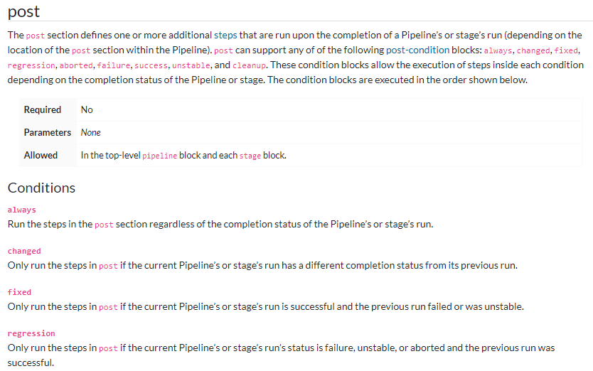

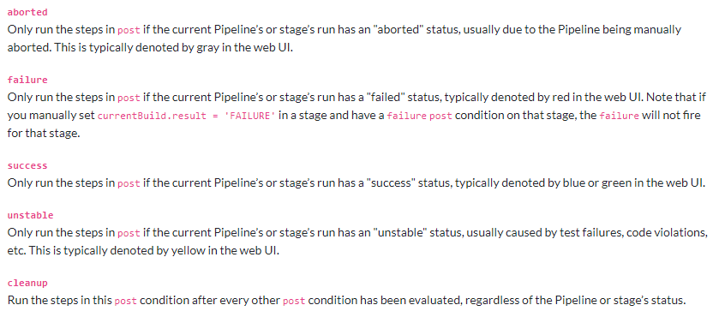

* We can set some post build actions as below.

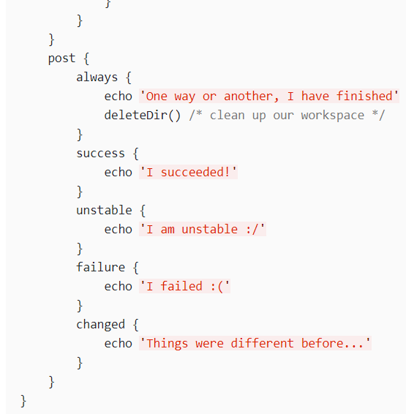

* We can generate pipeline syntax and add it to the post actions as below based on the success/failure/stable or unstable etc.

